
Southeast Asian Journal of Islamic Education
Volume 09, No. 01, June 2026
E-ISSN: 2621-5861, P-ISSN: 2621-5845
https://doi.org/10.21093/sajie.v9i1.13569

The Role of Ruangguru Online Tutoring in Islamic Religious Education (PAI) Learning for Madrasah Ibtidaiyah Students
Susanto¹*, Misbahul Khairani², Noor Malihah³, Ferli Septi Irwansyah⁴
Universitas Islam Negeri Sultan Aji Muhammad Idris Samarinda, Indonesia¹, Sekolah Tinggi Agama Islam Samarinda, Indonesia², Universitas Islam Negeri Salatiga, Indonesia³, Universitas Islam Negeri Sunan Gunung Djati Bandung, Indonesia⁴
¹risalahhub@gmail.com, ²suhaaranaa9@gmail.com, ³noormalihah_itah@yahoo.com, ⁴ferli@uinsgd.ac.id

Article History:
Received: May 28th, 2026 Accepted: June 28th, 2026 Published: June 30th, 2026

Abstract
This study examines the role of Ruangguru online tutoring in supporting Islamic Religious Education (PAI) learning among students at MI Al-Azhar Samarinda. Using a qualitative field research design, data were collected through observation, in-depth interviews, and documentation. Participants consisted of seven students who actively used Ruangguru for PAI learning, seven parents, one Ruangguru branch manager, and one marketing officer, selected purposively to represent student, family, and platform perspectives. Data were analyzed using the interactive model of Miles, Huberman, and Saldaña, including data condensation, data display, and conclusion drawing. The findings show that Ruangguru in Samarinda operates through an e-learning model centered on the Ruangngaji feature. This feature provides animated PAI learning videos, infographic summaries, Ruang Uji practice exercises, and learning progress reports. Ruangguru supports PAI learning by improving students’ understanding and learning outcomes, providing accessible learning facilities, increasing motivation and enthusiasm, helping students overcome difficulties in Qur’anic recitation and related materials, and enabling students to access learning resources anytime and anywhere. The study indicates that online tutoring platforms can serve as complementary learning resources for PAI at the madrasah ibtidaiyah level. However, broader studies involving different schools, platforms, and learning contexts are needed to strengthen the generalizability of these findings.
Keywords: e-learning, Islamic Religious Education, madrasah ibtidaiyah, online tutoring, Ruangguru
Copyright © 2026 Susanto, Misbahul Khairani, Noor Malihah, Ferli Septi Irwansyah
* Correspondence Address:
Email Address: risalahhub@gmail.com
Citation: Susanto, S., Khairani, M., Malihah, N., & Irwansyah, F. S. (2026). The Role of Ruangguru Online Tutoring in Islamic Religious Education (PAI) Learning for Madrasah Ibtidaiyah Students. Southeast Asian Journal of Islamic Education, 9(1), 71–84. https://doi.org/10.21093/sajie.v9i1.13569
- Introduction
Islamic Religious Education (PAI) is not merely a subject that requires students to memorize texts and religious arguments; it also serves as a means of character and moral formation from the primary education level. At the madrasah ibtidaiyah (MI) level, PAI learning should ideally foster both deep understanding and the internalization of Islamic values in students’ daily lives. To achieve this goal, an effective, varied, and experiential learning process is an essential need that cannot be overlooked (A. Firdaus et al., 2023).
Field realities show that many students encounter obstacles in learning PAI, mainly because the teaching methods used still predominantly rely on one-way lectures. In fact, PAI materials such as Qur’anic recitation, tajwid, and exemplary stories of the prophets require audio-visual media so that messages can be received more concretely by students. Without adequate media support, PAI learning tends to feel abstract and monotonous, which in turn affects students’ motivation and learning outcomes (Rusdi et al., 2025).
In this digital era, online tutoring has emerged as one possible solution to these challenges. Students no longer need to be physically present; they can access learning materials anytime and anywhere using internet-connected devices. Ruangguru, which is widely recognized as one of the leading online tutoring platforms in Indonesia, has become a preferred choice among families to help children improve their learning outcomes. The platform offers several advantages, including structured content, self-assessment features, and learning progress reports that parents can monitor regularly (Habsia et al., 2025).
Although research on Ruangguru has developed quite rapidly, most existing studies still focus on general subjects, particularly Mathematics and Natural Sciences, while studies in other fields remain relatively limited. Several studies, for instance, have examined the effectiveness of Ruangguru in improving mathematics learning outcomes (Ariyani & Setiaji, 2024; Muin et al., 2022; Ulfa, 2021). Other studies have discussed the use of digital learning media in broader educational contexts (Masluhah et al., 2022). However, studies that specifically examine the use of Ruangguru in Islamic Religious Education (PAI) learning at the madrasah ibtidaiyah level remain very limited.
In this context, the Ruangngaji feature within the Ruangguru platform becomes important to examine because it represents a specific digital learning service that is closely related to Islamic learning needs. Unlike general online tutoring features, Ruangngaji offers religious learning materials through animated videos, practice exercises, and learning summaries, which may help students understand PAI concepts more concretely and engagingly. Previous studies have shown that animated videos, interactive exercises, and digital learning media can enhance students’ motivation, engagement, and understanding (Bond et al., 2024; Chiu et al., 2022; Grájeda et al., 2023; Kong et al., 2024; Lin et al., 2023). This feature is particularly relevant for madrasah ibtidaiyah students, who often require visual, repetitive, and accessible learning support to strengthen their understanding of Qur’anic recitation, Islamic values, and religious practices (Aeni et al., 2024; Artati et al., 2023; Rizki, 2023; Shukri et al., 2020). Therefore, examining Ruangguru through its Ruangngaji feature can provide a more specific understanding of how online tutoring supports PAI learning at the primary Islamic education level.
This study specifically focuses on students of MI Al-Azhar Samarinda who use the Ruangguru platform to learn PAI. The two main questions addressed in this study are: (1) What is the PAI learning model implemented through Ruangguru online tutoring in Samarinda? and (2) What role does Ruangguru online tutoring play in supporting PAI learning among students of MI Al-Azhar Samarinda? The novelty of this study lies in its empirical evidence that digital tutoring platforms, which have long been associated with general subjects, can, in fact, make a real contribution to PAI learning at the primary education level (Pasha & Rahmanto, 2025).

- Literature Review
      - Online Tutoring and E-Learning in Education
Online tutoring can be understood as a structured form of academic assistance provided to students to help them prevent or overcome learning difficulties. Over time, this concept has evolved beyond conventional face-to-face interaction. The emergence of e-learning has created a new dimension that enables tutoring services to be delivered online without the constraints of time and place. Habsia et al. (2025) demonstrated that the implementation of e-learning in madrasah ibtidaiyah effectively promotes students’ independent learning, particularly when the platform is designed with features that align with their cognitive developmental stages.
Ruswandi et al. (2024) emphasized that the readiness of Islamic Religious Education (PAI) teachers to develop digital learning resources is one of the key factors for the successful integration of technology into religious education. In this regard, online tutoring platforms such as Ruangguru can complement existing limitations by providing well-structured learning content that students can access independently without relying entirely on the availability of teachers or parental assistance.
Previous studies on Ruangguru have primarily focused on general subjects. Ulfa (2021) found that the Ruangguru-based blended learning model significantly improved students’ learning independence and mathematics achievement at MAN 1 Aceh Besar. Similar findings were reported by Muin et al. (2022), who observed improvements in mathematics learning outcomes among elementary school students after using the Ruangguru application. Ariyani and Setiaji (2024) also found that the Ruangguru application could support students’ mathematical problem-solving ability when integrated with appropriate learning models.
Nevertheless, these studies mainly examined the effectiveness of Ruangguru in general subjects, particularly Mathematics and Natural Sciences. To date, studies specifically investigating the use of Ruangguru as an online tutoring platform for Islamic Religious Education (PAI), especially at the madrasah ibtidaiyah level, remain scarce. Consequently, there is a significant research gap regarding the implementation of digital tutoring platforms in PAI learning. This study seeks to address this gap by analyzing the PAI learning model implemented through the Ruangngaji feature and examining its role in supporting the learning process of students at MI Al-Azhar Samarinda.
      - Digital Learning Media and Islamic Religious Education (PAI)
The use of digital learning media has been proven to positively influence students’ motivation and learning outcomes across various educational levels. Rusdi et al. (2025) found that the use of digital media in elementary schools significantly enhanced students’ enthusiasm for learning because the learning process became more engaging, interactive, and less monotonous. This finding is particularly relevant to PAI learning, which has often been perceived as less engaging by some students.
More specifically, Kharismatunisa (2023) observed that PAI teachers who creatively utilized digital learning media succeeded in significantly increasing student engagement. Likewise, Rayhani et al. (2024) argued that integrating media and technology into PAI learning is not merely about transferring content to digital screens but also about expanding students’ learning experiences beyond the boundaries of the traditional classroom.
      - Infographics and Interactive Videos as Learning Media
Among various forms of digital learning media, interactive videos and infographics have received considerable attention in educational research. Gulo et al. (2024) demonstrated that interactive video media significantly improve students’ learning outcomes because audio-visual content is easier to comprehend and retain than conventional text-based materials. Similarly, Utami and Purnomo (2024) found that the use of animated videos significantly enhanced students’ learning motivation. Masluhah et al. (2022) and Faizah et al. (2023) further reported that infographic-based learning media effectively improve students’ learning outcomes and learning interest, including in religious education. Infographics simplify complex information into concise, visually appealing, and informative presentations, making them particularly suitable for summarizing PAI materials, which are often extensive and conceptually dense.
      - The Role of Parents and Accessibility in Digital Learning
Parental involvement in children’s learning is a crucial factor influencing educational success. However, not all parents have sufficient time or adequate knowledge to directly assist their children in learning Islamic Religious Education. Febriani et al. (2025) emphasized that parents’ digital literacy serves as an essential bridge that enables them to monitor their children’s learning progress effectively. Platforms such as Ruangguru, which provide learning progress reports, address this need by offering parents regular updates on their children’s academic development without requiring their physical presence throughout the learning process.

- Method
      - Research Design
This study employed a qualitative approach using a field research design. A qualitative approach was selected because this study aimed to explore and gain an in-depth understanding of the use of Ruangguru online tutoring in Islamic Religious Education (PAI) learning as it naturally occurs in the field, rather than measuring it quantitatively. Creswell and Poth (2018) explain that a qualitative approach enables researchers to explore the meanings individuals construct regarding social and human issues.
      - Participants of the Study
The participants were selected purposively to ensure that the data reflected a range of relevant perspectives. The participants consisted of: (1) seven students from MI Al-Azhar Samarinda who actively used the Ruangguru application for learning Islamic Religious Education (PAI) through its online tutoring program; (2) the parents of each participating student; (3) the Branch Manager of Ruangguru Samarinda; and (4) a Marketing Officer of Ruangguru Samarinda. This combination of participants provided a comprehensive understanding of the learning experience from the students' perspective, parental supervision from the parents' perspective, and platform management from the service provider's perspective.
      - Instruments
Data were collected using three complementary techniques. First, observations were conducted at MI Al-Azhar Samarinda and the Ruangguru Marketing Office in Samarinda to directly observe students' PAI learning activities using the Ruangguru application. Second, in-depth interviews were conducted with all participants using a semi-structured interview guide. These interviews explored students' learning experiences, their use of Ruangguru's features, learning motivation, parental involvement in supporting the learning process, and the role of Ruangguru in facilitating Islamic Religious Education (PAI) learning. Third, documentation was collected, including screenshots of the application's features, students' PAI scores before and after using Ruangguru, and other supporting documents. The trustworthiness of the data was ensured through source triangulation and methodological triangulation (Sugiyono, 2023).
      - Data Analysis Techniques
Data were analyzed using the interactive model developed by Miles et al. (2021), which consists of three cyclical components: data condensation, data display, and conclusion drawing and verification. Data condensation involved selecting, simplifying, and focusing raw data obtained from field notes, interview transcripts, and documents. Data display was carried out by presenting the organized data in the form of a systematic narrative. Conclusion drawing and verification were conducted continuously throughout the research process until credible and trustworthy conclusions were reached.

- Findings
Based on the triangulation of interview, observation, and documentation data, Ruangguru in Samarinda implements an e-learning-based learning model. Interviews with students, parents, and Ruangguru representatives revealed that the Ruangngaji feature serves as the primary learning medium used by students to study Islamic Religious Education (PAI). These findings were further supported by observations of the platform and documentation of its learning features, which demonstrated the integration of various instructional components, including learning videos, chapter summaries, practice exercises, and learning progress monitoring.
      - The Ruangngaji Feature
Ruangngaji is the core feature used by students of MI Al-Azhar Samarinda to learn Islamic Religious Education (PAI). This feature presents PAI instructional videos in an engaging animated-cartoon format designed to suit elementary school students. Each subtopic is accompanied by an interactive learning video that incorporates short formative assessments throughout the lesson. If a student answers a question incorrectly, the video is replayed to reinforce understanding; if the answer is correct, the student automatically proceeds to the next section.
Based on the interview findings, all participating students identified Ruangngaji as the feature they used most frequently for learning PAI. Observations also revealed that the learning materials were delivered through interactive animated videos complemented by short practice exercises for each subtopic. When students provided incorrect answers, the system prompted them to review the material before continuing to the next section. These findings indicate that the presentation of learning materials through interactive animated videos is one of the defining characteristics of Ruangngaji, as perceived by students, parents, and platform representatives, and serves as an important factor in supporting the PAI learning process.
As a practical example, in lessons covering short chapters or surahs of the Qur’an, the introductory video presents each surah along with its explanation, including guidance on makharij al-huruf, or the proper articulation points of Arabic letters. These pronunciation guides are illustrated through animated visualizations, making them easier for students who are beginning to learn Arabic pronunciation to understand and practice.

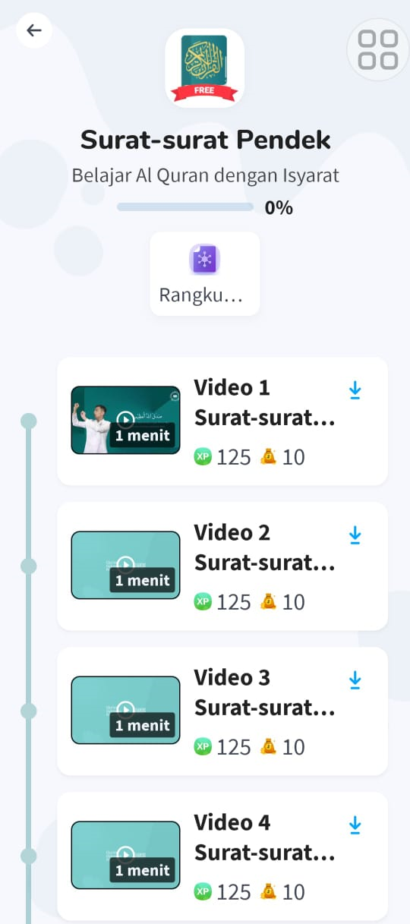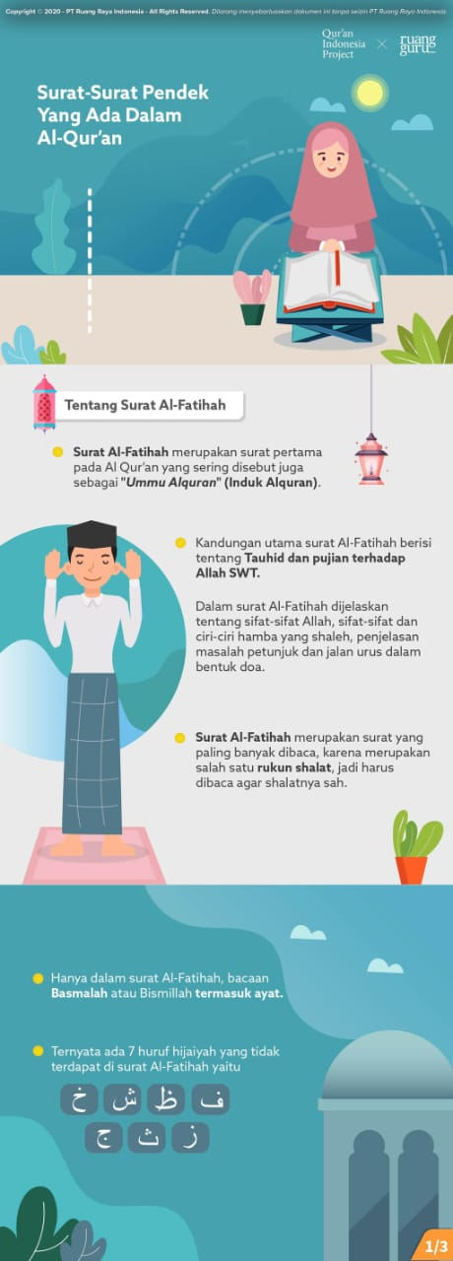

Figure 1. The Ruangngaji Feature in Ruangguru Online Tutoring

      - The Ruang Uji Feature
In addition to assessments integrated into the videos, Ruangguru provides the Ruang Uji feature as a separate question bank that students can access independently. This feature contains thousands of PAI practice questions organized by grade level and topic. Based on observation of the application, the Ruang Uji feature allows students to practice answering questions repeatedly, receive direct responses from the system, and review their understanding of the material independently. This feature supports students in monitoring their own learning progress and identifying topics that still require further practice.

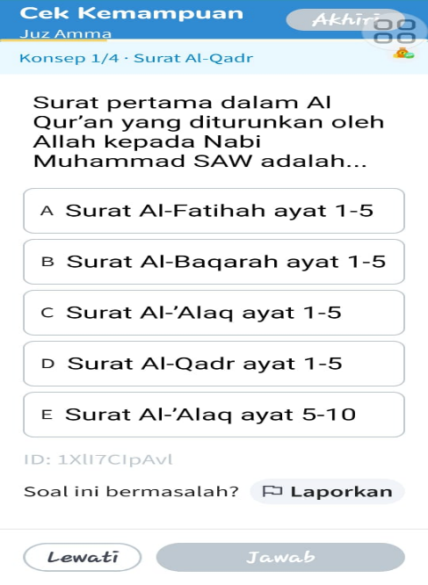
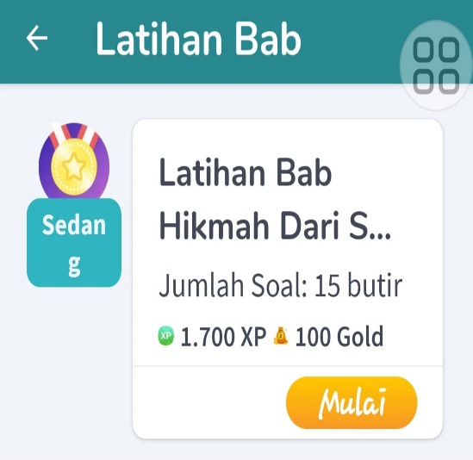

Figure 2. Example of Practice Exercises/Quizzes in Ruang Uji
      - Infographic Summary
Each lesson in the Ruangngaji feature is accompanied by an infographic summary that presents the key points of the instructional video in a concise and visually appealing format. The infographic summaries help students review the main ideas of each topic after watching the learning videos. Based on documentation of the application features, the summaries are designed with visual elements, short explanations, and structured content, making them easier for students to revisit when they need to strengthen their understanding of PAI materials.
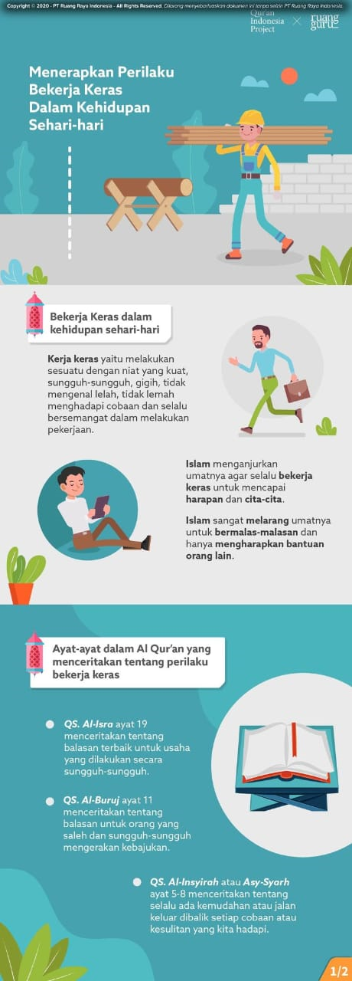

Figure 3. Infographic Summary in Ruangguru Online Tutoring
      - Learning Progress Report
Ruangguru provides a Learning Progress Report feature that periodically compiles students’ learning activity data, including the number of instructional videos watched, practice questions completed, total learning time, and average scores for each chapter. Based on interviews with parents, this feature helps them monitor their children’s learning activities without having to accompany them directly throughout the learning process. The report also provides students and parents with an overview of learning progress, making it easier to identify completed activities and areas that still require improvement.

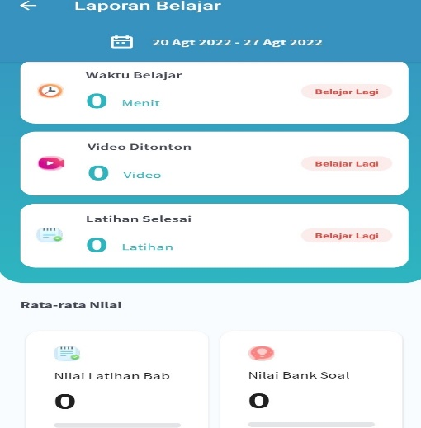

Figure 4. Learning Progress Report in Ruangguru Online Tutoring

This finding was supported by documentation of students’ scores, which showed an increasing trend after using the platform. However, the score data in this study served only as supporting data to strengthen the qualitative findings and were not analyzed as a quantitative measure of learning effectiveness.
Table 1. Improvement in PAI Learning Outcomes of MI Al-Azhar Samarinda Students
Student Name | Score Before | Score After
AK | 80 | 91
SA | 80 | 86
HZ | 82 | 90
IM | 78 | 80
CZH | 80 | 82
ZNK | 78 | 85
DR | 81 | 87
Average | 79 | 86
Table 1 shows that all students demonstrated improvements in their PAI scores after regularly using Ruangguru, with score increases ranging from 2 to 11 points. The overall average score increased from 79 before using the platform to 86 afterward, representing a substantial improvement in the context of the end-of-semester examination.

- Discussion
      - Helping Improve PAI Learning Outcomes
The findings indicate that the use of Ruangguru contributed to improving students’ understanding and learning outcomes in Islamic Religious Education (PAI). This improvement can be interpreted as the result of the platform’s ability to provide interactive learning experiences through animated videos, practice exercises, and immediate feedback. Although the increase in students’ scores cannot be interpreted as causal evidence because this study used a qualitative design, the score documentation strengthens the finding that students experienced positive learning development after regularly using Ruangguru. This is consistent with Rohmah & Tegeh (2022), who found that interactive multimedia can increase students’ interest and learning outcomes in PAI. Sapitri and Suriani (2025) also emphasize that one of the main advantages of interactive media is its ability to provide instant feedback, which in turn improves overall learning mastery. Similarly, Hasibuan et al. (2024) showed that the consistent use of audio-visual media improves students’ learning outcomes in Islamic Religious Education.
      - Providing Accessible Learning Facilities
The findings also show that Ruangguru functions as an accessible learning facility for students and families. This accessibility is important because not all parents have sufficient time or knowledge to accompany their children in learning PAI directly. Through digital access, students can study independently using smartphones or tablets, while parents can monitor learning progress through available reports. This indicates that Ruangguru not only support students’ individual learning but also strengthens parental involvement in children’s education. This finding is in line with Rayhani et al. (2024), who emphasize that easy access to learning media and technology is an essential prerequisite for ensuring that digital integration in PAI learning can be implemented inclusively. Febriani et al. (2025) also emphasized that parents’ access to information regarding their children’s digital learning progress is essential for providing appropriate and effective learning support. Apriyanti et al. (2023) further affirm that the availability of structured tutoring is positively correlated with improved academic achievement, particularly in materials that require regular practice, such as memorizing short surahs.
      - Motivating Students to Learn Without Pressure
Another important finding is that Ruangguru helped increase students’ willingness to learn PAI independently. Before using Ruangguru, several students tended to show passive attitudes toward conventional PAI learning. After using the Ruangngaji feature, students became more willing to open the application, complete practice exercises, and repeat learning materials independently. This suggests that digital tutoring can reduce the impression that PAI is merely a memorization-based subject and instead present it as a more engaging and enjoyable learning experience. The gamified interface, animated narratives, and interactive exercises appear to create a learning atmosphere that feels less pressuring for students. This finding supports Rusdi et al. (2025), who found that digital learning media can increase students’ motivation because the learning process becomes more engaging and less monotonous. Nisa and Aryanti (2023) also demonstrated that interactive learning media with immediate feedback can reduce students’ resistance toward subjects that were previously perceived as difficult.
      - Helping Students Overcome Difficulties in Learning PAI
The use of Ruangguru also helped students overcome difficulties in learning PAI, especially in reading and pronouncing Qur’anic verses correctly. Through interactive instructional videos that incorporate guidance on makharij al-huruf and animated visualizations, students receive more concrete support than verbal explanations alone. The ability to replay difficult materials also allows students to practice repeatedly without feeling embarrassed or hesitant. This is particularly important in PAI learning because students’ abilities in Qur’anic recitation are often diverse, and regular classroom instruction may not always provide enough time for individualized practice. Pasha and Rahmanto (2025) argue that interactive media in Islamic education, when designed in accordance with students’ characteristics and learning needs, are more effective in enhancing student engagement than conventional one-way instructional media. Likewise, Sapitri and Suriani (2025) explain that providing students with opportunities to practice without fear of judgment repeatedly fosters greater learning confidence, which ultimately contributes to improved mastery of the subject matter.
      - Enhancing Students' Enthusiasm for Learning PAI
The findings further indicate that the audio-visual and narrative elements in Ruangngaji contributed to students’ enthusiasm for learning PAI. Students who previously perceived PAI as a subject centered mainly on memorization began to experience it as a more interactive and enjoyable learning process. The presence of animated videos, dynamic storytelling, and Qur’anic learning content accompanied by sign language also shows that the platform attempts to present religious learning through multiple sensory modalities. This is relevant to the learning characteristics of madrasah ibtidaiyah students, who often need visual, auditory, and repeated exposure to understand religious materials more effectively. Syafaatussalamah et al. (2025) emphasize that students’ learning enthusiasm consistently increases when instructional materials are presented through multiple sensory modalities. Likewise, Melati et al. (2023) confirmed that animation-based instructional media are effective in enhancing students’ learning motivation.
      - Facilitating Access to PAI Learning Materials
Ruangguru also facilitates students’ access to PAI learning materials beyond classroom time. Students can access the Ruangngaji materials anytime and anywhere as long as their devices are connected to the internet. This flexibility allows students to review lessons repeatedly, especially when preparing for examinations or when they need to strengthen their understanding of specific materials. Infographic summaries also help students revisit the main ideas of the learning materials in a concise and visually organized form. Faizah et al. (2023) explain that infographic-based media play a significant role in enhancing students’ interest in learning religious education because visually presented content is easier to comprehend and remember. Similarly, Masluhah et al. (2022) found that infographic-based instructional media significantly improve students’ learning outcomes compared with the conventional presentation of materials in text-only format. Firdaus et al. (2022) also found that technology-based learning media that enable independent and repeated access to instructional materials promote more consistent mastery of the subject matter than learning methods that rely solely on face-to-face instruction. Likewise, Setiyadi et al. (2024) confirmed that the availability of practice exercises accessible at any time is one of the strongest predictors of improved academic achievement among elementary school students.
Although the majority of participants expressed positive perceptions of the Ruangngaji feature, the findings should be interpreted carefully. This study did not identify substantial differences in participants’ views regarding the challenges of using the platform, which may be influenced by the fact that all participants were active Ruangguru users and therefore had relatively positive experiences with the platform. In addition, Ruangguru should not be understood as a replacement for teachers, but as a complementary digital learning resource that can support classroom instruction, parental supervision, and students’ independent learning. Accordingly, future studies should involve participants with more diverse levels of platform usage, compare Ruangguru with other e-learning platforms, and examine the long-term effects of digital tutoring on students’ learning outcomes, learning motivation, digital literacy, and religious character development.

- Conclusion
This study demonstrates that an e-learning-based platform such as Ruangguru has the potential to support the transformation of Islamic Religious Education (PAI) learning at the Madrasah Ibtidaiyah (MI) level through flexible, student-centered digital technology. The findings indicate that Ruangguru can expand students’ opportunities for independent learning, enhance digital literacy in religious education, support teachers in integrating digital resources as a complement to face-to-face instruction, and help parents monitor their children’s learning progress more actively. These findings also provide useful input for educational technology developers and policymakers in designing digital learning platforms that are more responsive to the needs of religious and character education in Indonesia. However, this study was limited to one madrasah, involved a small number of participants, focused on a single learning platform, and was conducted within a limited period, so the findings cannot be generalized broadly or used to assess long-term effects. Therefore, future research should involve larger samples from different regions and educational levels, compare Ruangguru with other e-learning platforms, and employ experimental or mixed-methods designs to examine the long-term effects of digital tutoring on learning outcomes, motivation, digital literacy, and students’ religious character development.

References
Aeni, A. N., Abdullah, M., Fitriyatunnisa, F., Wulan, N., & Zahra, S. S. (2024). Development of Google Sites-Based Learning Media for Islamic Education Learning in Elementary Schools. AL-HAYAT Journal of Islamic Education, 8(2), 742–742. https://doi.org/10.35723/ajie.v8i2.594
Apriyanti, A., Hartini, H., & Fadila, F. (2023). Pengaruh Bimbingan dan Konseling Belajar terhadap Prestasi Belajar Matematika Siswa Sekolah Dasar. Jurnal Basicedu, 7(6), 3970–3979. https://doi.org/10.31004/BASICEDU.V7I6.6525
Ariyani, D., & Setiaji, H. A. (2024). Effectiveness of The Problem-based Learning Model Assisted with Ruangguru Application on Increasing Students’ Mathematical Problem Solving Ability. International Journal of Research in Mathematics Education, 2(1), 15–26. https://doi.org/10.24090/IJRME.V2I1.8948
Artati, A., Akmaluddin, A., & Sari, S. M. (2023). Implementation of The Kauny Method Using The ADLX -Introflex Approach to Improve The Quality of Tahfidz Learning Based on Digitalization at SD-IT Hafizul Ilmi. QALAMUNA Jurnal Pendidikan Sosial dan Agama, 15(2), 1191–1202. https://doi.org/10.37680/qalamuna.v15i2.3912
Bond, M., Khosravi, H., Laat, M. de, Bergdahl, N., Negrea, V., Oxley, E., Pham, P., Chong, S. W., & Siemens, G. (2024). A meta-systematic review of artificial intelligence in higher education: a call for increased ethics, collaboration, and rigour. International Journal of Educational Technology in Higher Education, 21(1). https://doi.org/10.1186/s41239-023-00436-z
Chiu, T. K. F., Xia, Q., Zhou, X., Chai, C. S., & Cheng, M. (2022). Systematic literature review on opportunities, challenges, and future research recommendations of artificial intelligence in education. Computers and Education Artificial Intelligence, 4, 100118–100118. https://doi.org/10.1016/j.caeai.2022.100118
Creswell, J. W., & Poth, C. N. (2018). Qualitative inquiry and research design: Choosing among five approaches ((4th ed.)). SAGE Publications.
Faizah, L. I., Ma’ruf, A., & Rosyidah, E. F. (2023). Media Pembelajaran Infografis dalam Membentuk Minat Belajar Siswa pada Mata Pelajaran Aqidah Akhlak di Madrasah Aliyah Raudhatul Banath Sidoarjo. Al-Ulum: Jurnal Pemikiran Dan Penelitian Keislaman, 10(1), Purwanza, Sena Wahyu, Aditya Wardhana, Ainul Mufid. https://journal.uim.ac.id/index.php/alulum/article/view/1644
Febriani, D. R., Indriyani, I., Shafa Fauziyah, A., Salsabila Divania, A., & Maulidah, N. (2025). Peran Literasi Digital dalam Pembentukan Etika Sosial di Dunia Maya pada Siswa SD. Jurnal Ilmiah Profesi Pendidikan, 10(1), 858–865. https://doi.org/10.29303/JIPP.V10I1.2962
Firdaus, A. A., Tabroni, I., & Megawati, I. (2022). Implementation of Quizizz Educational Game Media in Increasing Students’ Learning Motivation During the Covid-19 Pandemic in Islamic Religious Education Learning. Journal of Social Transformation and Regional Development, 4(2). https://doi.org/10.30880/JSTARD.2022.04.02.007
Firdaus, A., Amrullah, A., Robiatul Adawiyah, L., Yuliati Zakiah, Q., Al-Masthuriyah Sukabumi, S., & Gunung, S. (2023). Enhancing Learning Quality and Student Engagement: Utilizing Digital Technology in Islamic Education. International Journal of Nusantara Islam, 11(2), 206–2018. https://doi.org/10.15575/IJNI.V11I2.29960
Grájeda, A., Burgos, J., Olivera, P. C., & Sanjinés, A. (2023). Assessing student-perceived impact of using artificial intelligence tools: Construction of a synthetic index of application in higher education. Cogent Education, 11(1). https://doi.org/10.1080/2331186x.2023.2287917
Gulo, D. D. S., Laoli, B., Laoli, E. S., Lase, A., & Siswa. Pengembangan Media Pembelajaran Video Interaktif Untuk Meningkatkan Hasil Belajar. (2024). Pengembangan Media Pembelajaran Video Interaktif Untuk Meningkatkan Hasil Belajar Siswa. Jurnal Inovasi Pendidikan dan Teknologi Informasi (JIPTI), 5(2), 314–327. https://doi.org/10.52060/JIPTI.V5I2.2375
Habsia, A., Ertanti, D. W., & Zakaria, Z. (2025). Implementasi Pembelajaran Berbasis E-learning Madrasah dalam Membentuk Kemandirian Belajar Siswa Jenjang Kelas Atas di MIN 1 Kota Malang. JPMI: Jurnal Pendidikan Madrasah Ibtidaiyah, 7(2), 1–14. https://doi.org/https://doi.org/10.33474/jpmi.v7i2.28969
Hasibuan, N. L., Nurdiana, & Kartini, A. (2024). Improving Student Learning Outcomes through Audio-Visual Media in Islamic Education Learning at SD Negeri 26 Sampean. Jurnal Pendidikan Profesi Guru, 2(1), 93–99. https://doi.org/10.22373/JPPG.V2I1.6748
Kharismatunisa, I. (2023). Innovation and Creativity of Islamic Religious Education Teachers in Utilizing Digital-Based Learning Media. Scaffolding: Jurnal Pendidikan Islam Dan Multikulturalisme, 5(3), 519–538. https://doi.org/10.37680/SCAFFOLDING.V5I3.3700
Kong, S. C., Yang, Y., & Hou, C. (2024). Examining teachers’ behavioural intention of using generative artificial intelligence tools for teaching and learning based on the extended technology acceptance model. Computers and Education Artificial Intelligence, 7, 100328–100328. https://doi.org/10.1016/j.caeai.2024.100328
Lin, C.-C., Huang, A. Y. Q., & Lu, O. H. T. (2023). Artificial intelligence in intelligent tutoring systems toward sustainable education: a systematic review [Review of Artificial intelligence in intelligent tutoring systems toward sustainable education: a systematic review]. Smart Learning Environments, 10(1). Springer Nature. https://doi.org/10.1186/s40561-023-00260-y
Masluhah, Rizkiatul Afifah, K., & Hafid, A. (2022). Efektivitas Media Pembelajaran Berbasis Infografis terhadap Hasil Belajar Siswa pada Mata Pelajaran IPS. Jurnal Teori dan Praksis Pembelajaran IPS, 7(1), 11–20. https://doi.org/10.17977/UM022V7I12022P11
Melati, E., Dara Fayola, A., Putu Agus Dharma Hita, I., Muh Akbar Saputra, A., & Ninasari, A. (2023). Pemanfaatan Animasi sebagai Media Pembelajaran Berbasis Teknologi untuk Meningkatkan Motivasi Belajar. Journal on Education, 06(01), 732–741.
Miles, M. B., Huberman, A. M., & Saldaña, J. (2021). Qualitative Data Analysis. In SAGE (3rd ed.). SAGE. https://doi.org/10.4324/9781315697239-20
Muin, A., Firdaus, F., & Shari, A. M. (2022). Efektivitas Media Aplikasi Ruangguru terhadap Hasil Belajar Matematika Siswa Kelas V SDN 146 Bengo, Kecamatan Bengo, Kabupaten Bone. JPPSD: Jurnal Pendidikan dan Pembelajaran Sekolah Dasar, 2(3), 374–382. https://doi.org/10.26858/PJPPSD.V2I3.36018
Nisa, K., & Aryanti, L. D. (2023). Penggunaan Media Interaktif Terhadap Motivasi Belajar Siswa. Hijri, 12(1), 31–37. https://doi.org/10.30821/HIJRI.V12I1.16431
Pasha, A. S., & Rahmanto, M. A. (2025). Interactive Media in Islamic Education: Enhancing Engagement Amid Infrastructure Challenges at Muhammadiyah 12 Senior High School, Jakarta. Asatiza: Jurnal Pendidikan, 6(2), 118–131. https://doi.org/10.46963/ASATIZA.V6I2.2645
Rayhani, A., Hanapi, W., & Cahyadi, A. (2024). Pengembangan Teknologi dalam Desain Pembelajaran PAI. Berajah Journal, 4(3), 615–624. https://doi.org/10.47353/BJ.V4I3.352
Rizki, B. (2023). Learning Methodology of Tahfiz Al-Qur’an in Islamic Elementary School. SCAFFOLDING Jurnal Pendidikan Islam Dan Multikulturalisme, 5(1), 832–848. https://doi.org/10.37680/scaffolding.v5i1.3028
Rohmah, S., & Tegeh, I. M. (2022). Multimedia Interaktif Untuk Meningkatkan Minat dan Hasil Belajar PAI. Jurnal Edutech Undiksha, 10(2), 215–224. https://doi.org/10.23887/JEU.V10I1.43365
Rusdi, H., Ervianti, R., Adrias, A., & Zulkarnaini, A. P. (2025). Pengaruh Media Pembelajaran Digital Terhadap Motivasi Belajar Siswa Sekolah Dasar. Pendas: Jurnal Ilmiah Pendidikan Dasar PP8, 10(2), 347–360.
Ruswandi, A., Firdaus, M. A., Ruswandi, R., & Mahyani, A. (2024). Proceedings of the 7th International Conference on Learning Innovation and Quality Education (ICLIQE). Readiness of Digital Learning Documents on Islamic Religious Education Teachers in Madrasah, 906–918. https://doi.org/10.2991/978-2-38476-301-6_88
Sapitri, S., & Suriani, A. (2025). Efektivitas Media Pembelajaran Interaktif dalam Meningkatkan Minat Belajar Siswa SD. Pragmatik : Jurnal Rumpun Ilmu Bahasa Dan Pendidikan , 3(3), 282–292. https://doi.org/10.61132/PRAGMATIK.V3I3.1844
Setiyadi, D., Rohayati, I., & Zubaidi. (2024). Upaya Meningkatkan Prestasi Belajar Matematika dengan Menggunakan PBL Berbantuan Media Sempoa pada Operasi Hitung Siswa MI. JISPE Journal of Islamic Primary Education, 5(01), 30–44. https://doi.org/10.51875/JISPE.V5I01.297
Shukri, N. H. A., Nasir, M. K. M., & Razak, K. A. (2020). Educational Strategies on Memorizing the Quran: A Review of Literature [Review of Educational Strategies on Memorizing the Quran: A Review of Literature]. International Journal of Academic Research in Progressive Education and Development, 9(2). https://doi.org/10.6007/ijarped/v9-i2/7649
Sugiyono. (2023). Buku Metode Penelitian Pendidikan (Kuantitatif, Kualitatif, Kombinasi, dan Penelitian Pendidikan) (2nd ed.). Alfabeta.
Syafaatussalamah, A., Eka Salsabilla, D., & Raya Mojosari, J. (2025). Efektivitas Penggunaan Media Digital dalam Meningkatkan Motivasi Belajar Siswa Sekolah Dasar. Al-Tarbiyah : Jurnal Ilmu Pendidikan Islam, 3(3), 11–24. https://doi.org/10.59059/AL-TARBIYAH.V3I3.2479
Ulfa, M. (2021). Blended Learning Berbasis Bimbel Online “Ruangguru” dalam Meningkatkan Kemandirian Belajar dan Hasil Belajar Matematika di MAN 1 Aceh Besar. Intelektualita: Journal of Education Sciences and Teacher Training, 7(01). https://doi.org/10.22373/JI.V7I01.9919
Utami, H. C., & Purnomo, A. R. (2024). Penggunaan Video Animasi Powtoon untuk Meningkatkan Motivasi Siswa pada Materi Bumi dan Tata Surya. Jurnal Basicedu, 8(4), 3094–3103. https://doi.org/10.31004/BASICEDU.V8I4.8506

